|  |  |  |  |
| --- | --- | --- | --- |
| Input | Expected Output | Actual Output | Pass? |
| 2015 Salesman Rosenberg,David 2800 97000  2015 Employee Tsuboi,Anthony 3150  2014 Executive Hernandez,Antonio 5870 60 | ---EMPLOYEE DATA FOR 2014---  Executive  Hernandez, Antonio  $5870  $100440  $60  ---EMPLOYEE DATA FOR 2015---  Salesman  Rosenberg, David  $2800  $35540  $97000  Employee  Tsuboi, Anthony  $3150  $37800  The average salary for 2014 was $100440  The average salary for 2015 was $36670 | ---EMPLOYEE DATA FOR 2014---  Executive  Hernandez, Antonio  $5870  $100440  $60  ---EMPLOYEE DATA FOR 2015---  Salesman  Rosenberg, David  $2800  $35540  $97000  Employee  Tsuboi, Anthony  $3150  $37800  The average salary for 2014 was $100440  The average salary for 2015 was $36670 | Yes |
| 2014 Employee Salazar,Tommy 2540  2014 Salesman Reynolds,Caden 2975 85500  2015 Employee Robinson,Terry 3090  2014 Executive Oviedo,Johnathon 6500 28 | ---EMPLOYEE DATA FOR 2014---  Employee  Salazar, Tommy  $2540  $30480  Salesman  Reynolds, Caden  $2975  $37410  $85500  Executive  Oviedo, Johnathon  $6500  $78000  $28  ---EMPLOYEE DATA FOR 2015---  Employee  Robinson, Terry  $3090  $37080  The average salary for 2014 was $48630  The average salary for 2015 was $37080 | ---EMPLOYEE DATA FOR 2014---  Employee  Salazar, Tommy  $2540  $30480  Salesman  Reynolds, Caden  $2975  $37410  $85500  Executive  Oviedo, Johnathon  $6500  $78000  $28  ---EMPLOYEE DATA FOR 2015---  Employee  Robinson, Terry  $3090  $37080  The average salary for 2014 was $48630  The average salary for 2015 was $37080 | Yes |
| 2014 Employee Eichmann,Jared 3500  2015 Salesman Velez,Richard 3300 120000  2014 Executive Ray,Jacob 6000 70  2014 Salesman Jones,Janet 2750 140000  2015 Executive Armstrong,Daniel 7100 35 | ---EMPLOYEE DATA FOR 2014---  Employee  Eichmann, Jared  $3500  $42000  Executive  Ray, Jacob  $6000  $102000  $70  Salesman  Jones, Janet  $2750  $35800  $140000  ---EMPLOYEE DATA FOR 2015---  Salesman  Velez, Richard  $3300  $42000  $120000  Executive  Armstrong, Daniel  $7100  $85200  $35  The average salary for 2014 was $59933  The average salary for 2015 was $63600 | ---EMPLOYEE DATA FOR 2014---  Employee  Eichmann, Jared  $3500  $42000  Executive  Ray, Jacob  $6000  $102000  $70  Salesman  Jones, Janet  $2750  $35800  $140000  ---EMPLOYEE DATA FOR 2015---  Salesman  Velez, Richard  $3300  $42000  $120000  Executive  Armstrong, Daniel  $7100  $85200  $35  The average salary for 2014 was $59933  The average salary for 2015 was $63600 | Yes |

Screen Capture of me successfully compiling and executing my Java program:

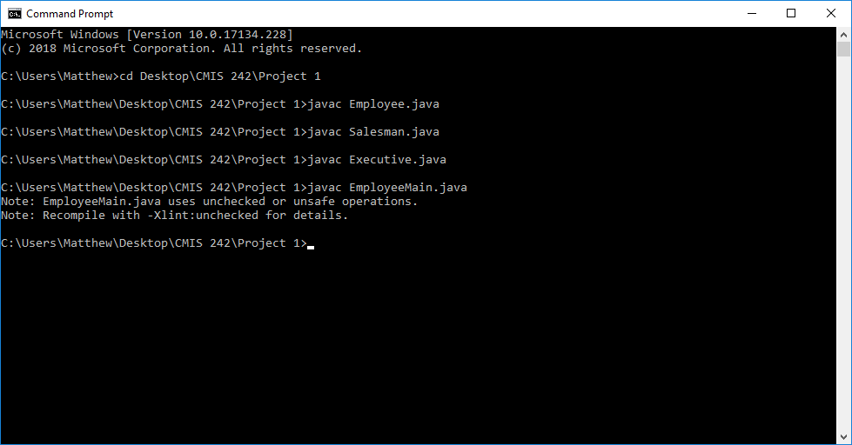

*Despite the advisories, the java program executes without any issues

Screen Capture of Test Case #1:

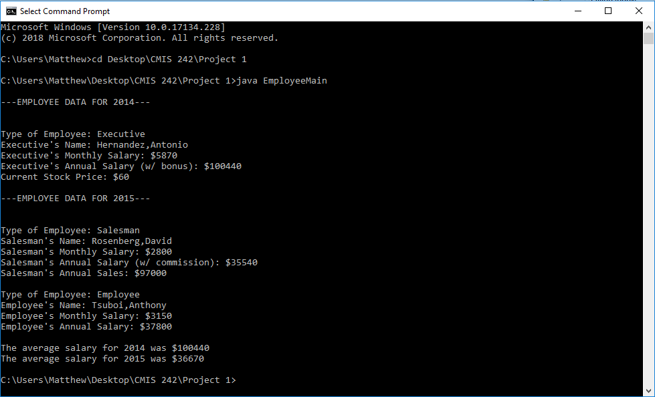

Screen Capture of Test Case #2:

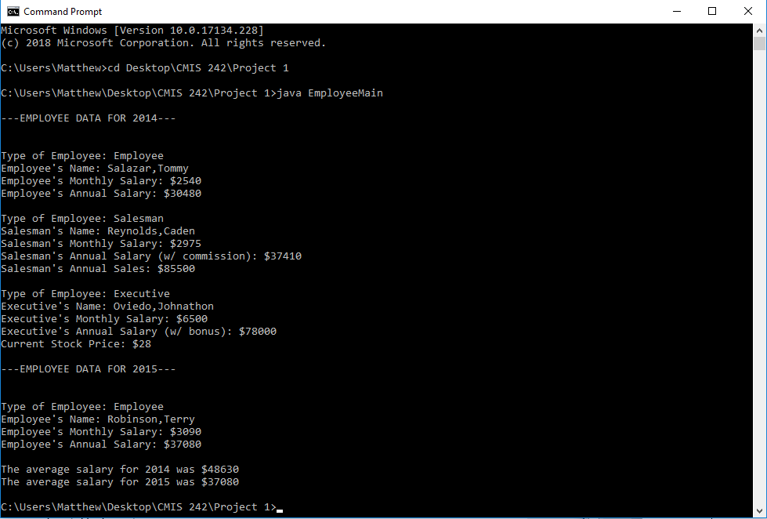

Screen Capture of Test Case #3:

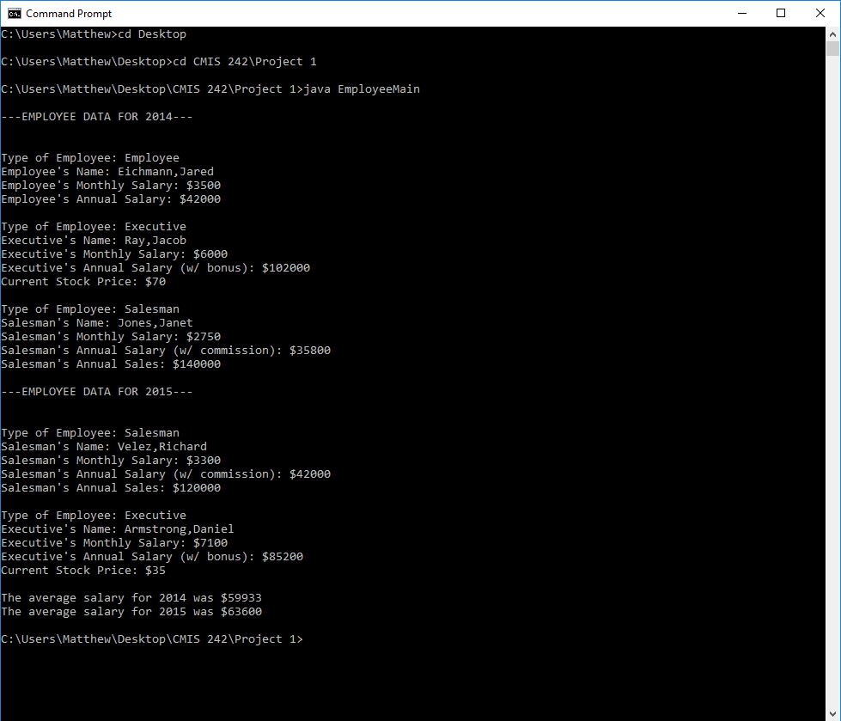

Screen Capture of Read File (Input) for Test Case #1:



Screen Capture of Read File (Input) for Test Case #2:



Screen Capture of Read File (Input) for Test Case #3:

